I’ve been taking driving classes these days to prepare for my driving test. I’ve been struggling for one thing – why is the blinker for turning is designed as up for right and down for left? Every time before making a turn, I need to pause for 2 seconds to think about which direction, and I often make mistakes. So I spent some time looking into it.

The first electric turn signal was introduced by Buick in 1939, then by the 1950s, most major automobile manufacturers had adopted electric turn signal, making it a common feature in vehicles worldwide.

The common practice of the blinker is turning up for right and down for left, and the reason behind this design is mostly due to the ergonomic reasons. When drivers turn left, they move the steering wheel in the counter clockwise direction, lower the left hand, so they can press down the blinker naturally. Likewise, when drivers turn right, they move the steering wheel in the clockwise direction and raise the left hand, so they can lift the blinker naturally. But the issue is, normally we need to turn on the signal 10 seconds before moving the steering wheel to make the turn.

After decades of using traditional stalk, some companies want to make some changes. For example, Tesla’s Model 3 “Highland” has replaced the traditional turn signal stalk with buttons on the steering wheel, showcasing a shift towards more streamlined and user-friendly designs. This was not Tesla’s first experiment in deleting stalks. The brand’s yoke-equipped Model S, launched in 2021, also ditched them in favour of steering wheel-mounted controls.

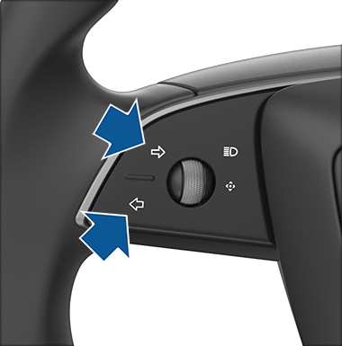 from model 3 owner manual

<https://www.tesla.com/ownersmanual/model3/en_us/GUID-1C209641-AA23-47AC-B0D1-3FE3779CF222.html>

<https://www.youtube.com/watch?v=yA2dSHu-hns>

After receiving strong criticisms from customers for nearly two years, they decided to bring the stalk back into the newer version of Model 3. And for the existing users, Tesla will offer a turn signal stalk retrofit that costs around 350 USD.

<https://www.electrifying.com/blog/article/tesla-officially-brings-back-model-3-indicator-stalks-but-there-s-a-catch?utm_source=chatgpt.com>

Also, Tesla offers a turn signal stalk retrofit for existing Model 3 vehicles, and it costs around 350 USD.

<https://www.notateslaapp.com/news/3035/tesla-brings-back-turn-signal-stalk-on-model-3>